# Project A5MMS

Project Documentation Submitted

To the Faculty of School of

Computing and Information Technologies Of

Asia Pacific College

In Partial Fulfillment of the Requirements for the subject

Applied Projects 2 or Software Development

By

Lopez, Carlucenne Alipao

Naperi, Jayson

Dela Cuesta, Georgette  
Rocero, Earl Jerome

**ASIA PACIFIC COLLEGE**

# Approval Sheet

PROJECT A5MMS

Prepared and Submitted by:  
Lopez, Carlucenne Alipao

Naperi, Jayson

Dela Cuesta, Georgette  
Rocero, Earl Jerome

In Partial Fulfilment of the Requirements for the Degree of

Bachelor of Science in

Examined and Recommended for Acceptance and Approval for Research/Capstone Presentation

Mr. Jose Quesada

Adviser

Panel of Judges

___________________________

Chairperson

Panel Members

Acceptance and Approved in partial fulfillment of the requirements for the degree of Bachelor of Science

Table of Contents

Project A5MMS 1

Approval Sheet 2

Executive Summary 4

I. Introduction 5

**1.1** **Project Context** 5

**1.2** **Purpose and Description** 5

**1.3** **Objectives** 5

**1.4** **Scope and Limitations** 5

II. Review of Related Literature/Systems 6

III. Technical Background 7

IV. Methodology, Results and Discussion 7

**4.1** **Requirements Analysis** 7

**4.2** **Requirements Documentation** 8

**4.3** **Design of Software, Systems, Product, and/or Processes** 8

**4.4** **Development and Testing, where applicable** 8

**4.5** **Description of the Prototype, where applicable** 8

**4.7**  **Implementation Plan (Infrastructure/Deployment) where needed** 8

**4.8** **Implementation Results, where applicable** 8

V. Conclusions and Recommendations 9

VI. Appendices 9

# Executive Summary

Project Area 5 Manpower Management Services is a Human Resource Management system for Area 5 Manpower Management Services (A5MMS) that will improve and decrease the work time on managing their applicants and clients for their business.

The system will be a full replacement of the manual encoding system of the corporation, meaning that the new system will automate the corporation’s way of managing their applicants. The admin of the system can add, update and delete client information as well as applicant information. The admin can also keep track on the applicant’s requirements and its status. Applicants of the corporation can also view their profile and keep on track of their status. The objective of this project is to the efficiency of handling the corporation’s applicants and clients.

# Introduction

## **Project Context**

Area 5 Manpower Management Services (A5MMS) is a corporation, formed and organized under the laws of the Republic of the Philippines, duly registered with the Security and Exchange Commission (SEC) and licensed to operate a manpower/janitorial services. The team aims to propose a web application which is the Human Resource Management Application that focuses on managing the data of their applicants and clients.

## **Purpose and Description**

The purpose of the project is to make a Human Resource Management System that will help minimize the manual encoding of the corporation. The system will completely automate the work of A5MMS making data handling a lot easier and efficient.

The information of the applicants of the A5MMS and their clients are stored within the system and can be modified anytime through online and local area network. The applicants can view their information and status anytime and will also have their own accounts.

## **Objectives**

* **General Objective**
* To be able to design and develop a web-based Human Resource Management System focusing on the Human Resource application for the A5MMS.
* **Specific Objective**
* To increase the number of qualified applicants assessed by the agency by 90% in annual basis.
* To provide faster transaction on application process of applicants by less than a day.

## **Scope and Limitations**

The proposed solution to the said problem of the company is to automate their processes to lessen the paper work and increase efficiency of its processes. Therefore the project will only revolve on the Human Resource aspect of the corporation. The system will be able to store applicant information and client information. Admins will only have privileges in terms of editing the information and altering applicant statuses. The Applicant will have an account (without admin privilege) after filling up the application form which the applicant can view his/her information as well as his/her job history.

# Review of Related Systems

|  |  |  |  |
| --- | --- | --- | --- |
|  | **Ramco** | **WebHR** | **Project A5MMS** |
| **Description** | A global talent management application that has been designed to facilitate a changing work environment. Its flexible architecture is designed to handle proliferating employment, measurement, and wage models, and it provides an integrated HR services experience. | Facilitates all functions of the Human Resource Department that deals with recruitment, employees' management, payroll, performance, training etc. | A Human Resource Management System that focuses on the job inquiry, application, employment and payroll process. |
| **Features / Functions** | * Time attendance * Payroll * Talent management * Recruitment * Planning & Analytics | * Feature Rich Social HR * Complete Recruitment Solution * Employees Self Service * Extremely User Friendly * Effortless Payroll * Employees Attendance / Biometrics * Very Cost Effective * Comprehensive Reports & Graphs * Extensive Leaves Management * Online Job Portal * Extensive Employee Profile * Customizable Data Fields * Documents Managements * Reports Generator | * Online Job Inquiry * Online Application Form * HR Management * Import employee attendance * Payroll and Pay Slip |

# Technical Background

The web application is developed using bootstrap, PHP, JavaScript, CSS and HTML. The database used by the web application is MySQL Server. The web application will run at windows operating system from XP and up.

# Methodology, Results and Discussion

## **Requirements Analysis**

The team conducted interviews from the A5MMS corporation regarding on the issues they had been experiencing in their business and these are:

* The need of A5MMS’ clients for highly qualified employees
* The need for accessible information on available jobs
* The need to improve the manual and time consuming processes that they experience as of the moment.

With the new A5MMS System, it will help the corporation greatly on minimizing on the said problems.

## **Requirements Documentation**

*Refer to VI Appendices~*

## **Design of Software, Systems, Product, and/or Processes**

*Refer to VI Appendices~*

## **Development and Testing, where applicable**

The Human Resource application is tested to make sure that it can add, edit and delete applicant and client data of the A5MMS properly without any discrepancies. All the errors that are met within the testing were fixed.

## **Description of the Prototype, where applicable**

The prototype is a basic web application where you can log-in as an admin and add, delete, and modify data from the A5MMS Corporation from applicant data to client data. As for the user interface, it is simple and easy to use consisting of tabs, sections and buttons that are needed throughout the system.

## **4.7 Implementation Plan (Infrastructure/Deployment) where needed**

For the implementation, it will initially start by training the admins of the A5MMS corporation on how to use and navigate throughout the system. There would be a handover of some documentations of the system such as the user manual. And finally, when the training and briefing is complete, the system will be handed over to the A5MMS system.

## **Implementation Results, where applicable**

What will likely happen if the system has been fully implemented, the A5MMS corporation will experience a more organized and efficient way in handling their data. There would be less paperwork and faster processes in the corporation thanks to the system.

# Conclusions and Recommendations

In conclusion, “Project A5MMS” already have a working Human Resource Management application. The applicants and the clients of the A5MMS can now be added within the system. Admin can change and edit the status of the applicants as well as edit the corporation’s client information.

When implementation of the system comes into place, the admin of the system is recommended to be trained by the team regarding on how to use the system. Not only that the admin will be trained but also a user manual will handed over to them for references.

# Appendices

**UML DIAGRAMS**

**Work Breakdown Structure**

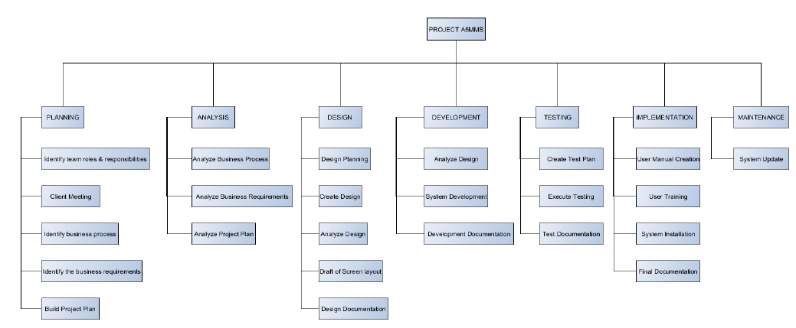

**Gantt Chart**

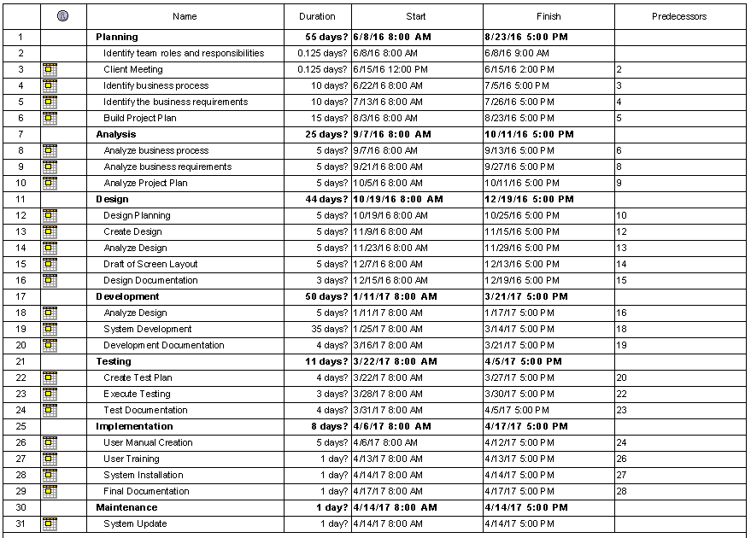

**Organizational Chart**

* **Agency Organizational Chart** 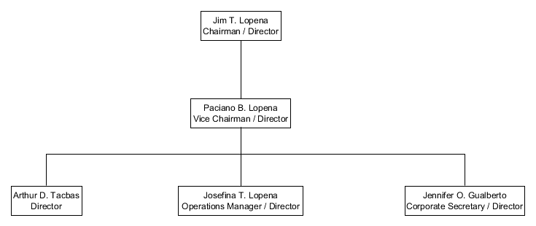
* **Team Organizational Chart**

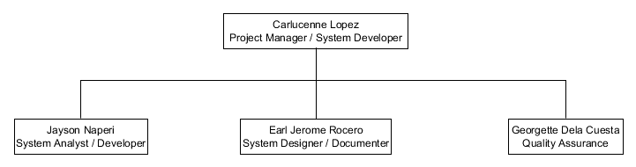

**Roles and Responsibilities**

|  |  |
| --- | --- |
| **ROLES** | **RESPONSIBILITIES** |
| Project Manager | * Leads and Manages the team * Plans the project requirements * Assigns the roles and responsibilities * Monitors the project progress |
| System Analyst | * Analyzes client’s business process * Analyzes the system requirements * Analyzes the system structure |
| System Designer | * Follow and creates diagrams analyzed by the system analyst |
| System Developer | * Follow the diagrams created by the system designer and developed it into a system |
| System Documenter | * Creates the project documentation including the business case, diagrams, development and design phase |
| Quality Assurance | * Assures the correct and appropriate analyzation, design, developed system, and documentation * Leads and Conducts System Testing |

**Functional Decomposition Diagram**

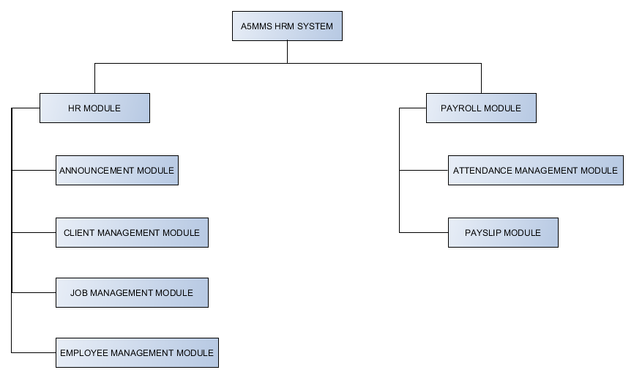

**Context Diagram**

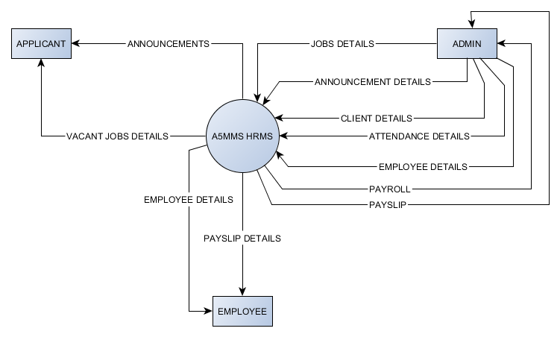

**Data Flow Diagram**

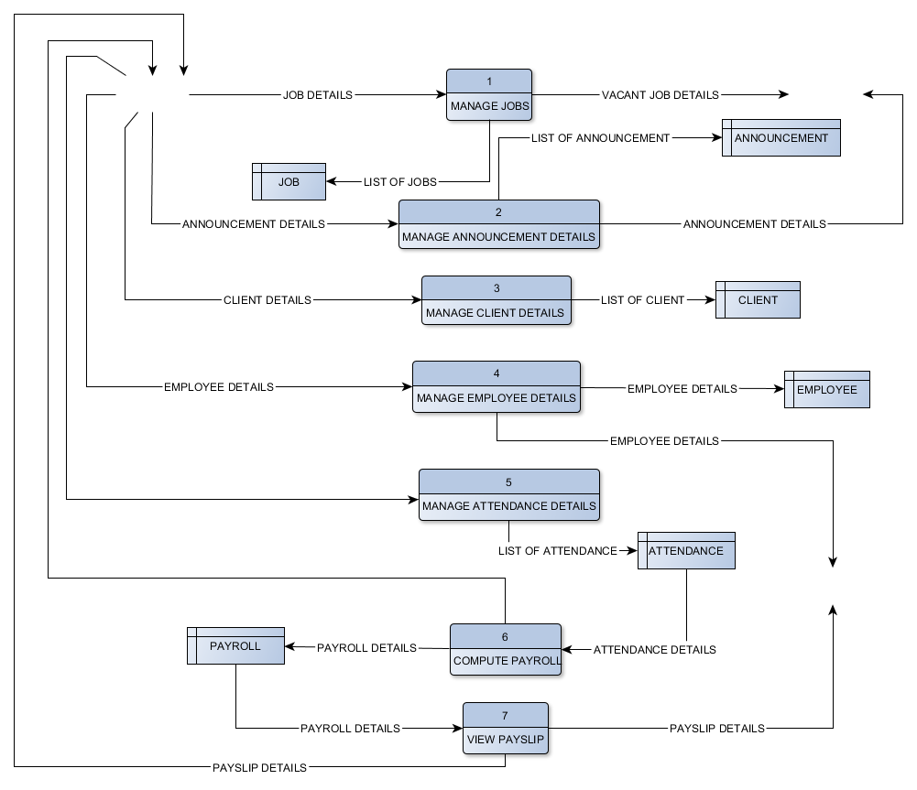

**Entity-Relationship Diagram**

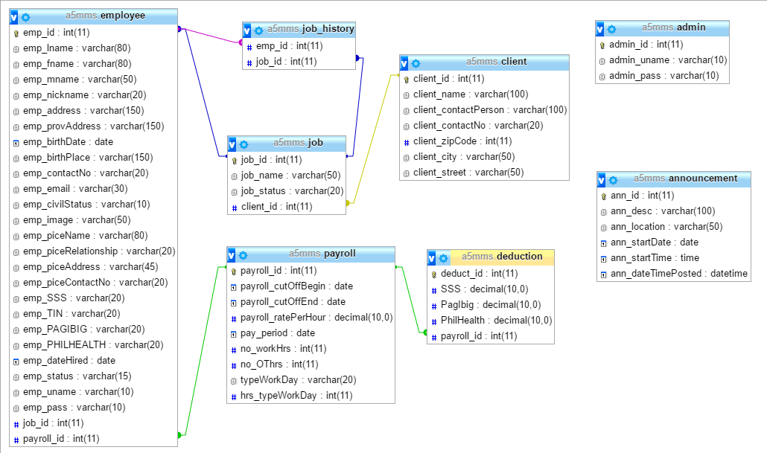

**Use Case Diagram**

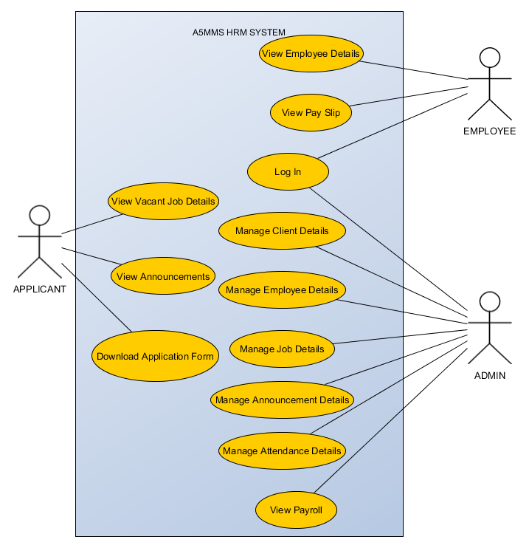

**Use Case Narrative Description**

|  |  |  |  |
| --- | --- | --- | --- |
| **USE CASE NAME** | | View Vacant Job Details | |
| **ACTOR** | | Applicant | |
| **DESCRIPTION** | | Describes the process in viewing the vacant job details. | |
| **SUCCESSFUL** **COMPLETION** | ACTOR  1. Applicant access the system.  3. Applicant selects vacant jobs.  5. Applicant selects desired vacant job. | | SYSTEM  2. System displays the vacant jobs, announcements, and download application form.  4. System access job module and displays list of vacant jobs.  6. System displays details of vacant job. |
| **ALTERNATIVE** | | * 1. Applicant can walk – in/contact the agency regarding on the vacant job.   6.1 Applicant search for another job online if he/she doesn’t like the listed vacant jobs in the system. | |
| **PRE – CONDITION** | | Applicant searches for a job. | |
| **POST – CONDITION** | | Applicant knows what are the vacant job the agency offers and what company he/she is applying for. | |
| **ASSUMPTION** | | List of vacant job and details will be viewed in the system. | |

|  |  |  |  |
| --- | --- | --- | --- |
| **USE CASE NAME** | | Download Application Form | |
| **ACTOR** | | Applicant | |
| **DESCRIPTION** | | Describes the process downloading the application form in the system. | |
| **SUCCESSFUL** **COMPLETION** | ACTOR  1. Applicant access the system.  3. Applicant selects download application form.  5. Applicant downloaded the application form. | | SYSTEM  2. System displays the vacant jobs, announcements, and download application form.  4. System downloads application form. |
| **ALTERNATIVE** | | * 1. Applicant can walk-in to the agency to get an application form and fill up. | |
| **PRE – CONDITION** | | Applicant opens the system. | |
| **POST – CONDITION** | | Downloaded the application form and fill up. | |
| **ASSUMPTION** | | The application form is up to date and can be downloaded in the system. | |

|  |  |  |  |
| --- | --- | --- | --- |
| **USE CASE NAME** | | View Announcements | |
| **ACTOR** | | Applicant | |
| **DESCRIPTION** | | Describes the process viewing of announcements in the system. | |
| **SUCCESSFUL** **COMPLETION** | ACTOR  1. Applicant access the system.  3. Applicant selects announcements.  5. Applicant views the announcement details such as interviews and trainings. | | SYSTEM  2. System displays the vacant jobs, announcements, and download application form.  4. System access application module and displays announcements. |
| **ALTERNATIVE** | | 1.1 Applicant can walk – in/contact the agency regarding on the announcements of interview and training.  1.2 HR Admin contact the applicants for the announcements of interviews and trainings. | |
| **PRE – CONDITION** | | Applicant applied a job. | |
| **POST – CONDITION** | | Applicant notified about the announcements. | |
| **ASSUMPTION** | | Up to date announcements posted in the system. | |

|  |  |  |  |
| --- | --- | --- | --- |
| **USE CASE NAME** | | View Employee Details | |
| **ACTOR** | | Employee | |
| **DESCRIPTION** | | Describes the process of viewing the employee details. | |
| **SUCCESSFUL** **COMPLETION** | ACTOR  1. Employee access the system.  3. Employee selects view employee details.  5. Employee views the employee details. | | SYSTEM  2. System displays the employee details and pay slip details.  4. System access employee management module and display the employee details. |
| **ALTERNATIVE** | | 1.1 Employee can walk – in to the agency regarding on the employee details. | |
| **PRE – CONDITION** | | Employee logged in to the system. | |
| **POST – CONDITION** | | Employee successfully views employee details. | |
| **ASSUMPTION** | | Displayed employee details. | |

|  |  |  |  |
| --- | --- | --- | --- |
| **USE CASE NAME** | | View Pay Slip | |
| **ACTOR** | | Employee | |
| **DESCRIPTION** | | Describes the process of viewing the payslip details. | |
| **SUCCESSFUL** **COMPLETION** | ACTOR  1. Employee access the system.  3. Employee selects view pay slip details.  5. Employee selects pay period.  6. Employee views pay slip. | | SYSTEM  2. System displays the employee details and pay slip details.  4. System access payroll module and display the pay periods.  5. System displays the pay slip in a specific pay period. |
| **ALTERNATIVE** | | 3.1 Employee walk – in to the agency to get pay slip. | |
| **PRE – CONDITION** | | Employee logged in to the system. | |
| **POST – CONDITION** | | Employee successfully views pay slip. | |
| **ASSUMPTION** | | System computed payroll every cut-off. | |

|  |  |  |  |
| --- | --- | --- | --- |
| **USE CASE NAME** | | Log In | |
| **ACTOR** | | Admin /Employee | |
| **DESCRIPTION** | | Describes the process of logging – in to the system of the Admin and Employee. | |
| **SUCCESSFUL** **COMPLETION** | ACTOR  1 Admin/Employee log in to the system  3. Admin/Employee accessed the system. | | SYSTEM  2. System verifies the account. |
| **ALTERNATIVE** | | 2.1 System allows the admin / employee to verify the account. | |
| **PRE – CONDITION** | | Admin/Employee has an accessed to the system. | |
| **POST – CONDITION** | | Admin/Employee successfully log in to the system. | |
| **ASSUMPTION** | | Admin/Employee has an account. | |

|  |  |  |  |
| --- | --- | --- | --- |
| **USE CASE NAME** | | Manage Employee Details | |
| **ACTOR** | | Admin | |
| **DESCRIPTION** | | Describes the process of managing the employee details. | |
| **SUCCESSFUL** **COMPLETION** | ACTOR  1. Admin access the system.  3. Admin selects employee management module.  5. Admin selects manage employee details.  7.Admin selects a client.  9. Admin selects an employee.  11. Admin manages employee details.  13. Admin views employee details. | | SYSTEM  2. System displays the job assignment, application, and employee management modules.  4. System displays the manage employee details.  6. System displays list of agency’s clients.  8. System displays list of employees working on the client.  10. System allows the HR Admin to manage employee details.  12. System displays updated employee details. |
| **ALTERNATIVE** | | 1.1 Admin contact the employee regarding on the employee details. | |
| **PRE – CONDITION** | | Employee sent employee details. | |
| **POST – CONDITION** | | Admin updated employee details. | |
| **ASSUMPTION** | | Admin received the employee details. | |

|  |  |  |  |
| --- | --- | --- | --- |
| **USE CASE NAME** | | Manage Job Details | |
| **ACTOR** | | Admin | |
| **DESCRIPTION** | | Describes the process of managing the job details. | |
| **SUCCESSFUL** **COMPLETION** | ACTOR  1. Admin access the system.  3. Admin selects job module.  5. Admin selects manage job details.  7.Admin selects a client.  9. Admin selects a job.  11. Admin manages job details.  13. Admin views job details. | | SYSTEM  2. System displays the job assignment, application, and employee management modules.  4. System displays the manage job details.  6. System displays list of agency’s clients.  8. System displays list of jobs given by the client.  10. System allows Admin to manage job details.  12. System displays updated job details. |
| **ALTERNATIVE** | | 1.1 Admin contact / personally meet the client regarding on the job details. | |
| **PRE – CONDITION** | | Client sent job details. | |
| **POST – CONDITION** | | Admin updated job details. | |
| **ASSUMPTION** | | Admin received the job details from the client. | |

|  |  |  |  |
| --- | --- | --- | --- |
| **USE CASE NAME** | | Manage Announcement Details | |
| **ACTOR** | | Admin | |
| **DESCRIPTION** | | Describes the process of managing the announcement details. | |
| **SUCCESSFUL** **COMPLETION** | ACTOR  1. Admin access the system.  3. Admin selects application module.  5. Admin selects manage announcement details.  7. Admin posts announcement details.  9. Admin views announcements details. | | SYSTEM  2. System displays the job assignment, application, and employee management modules.  4. System displays the manage applicant and announcement details.  6. System allows the HR Admin to manage announcement details.  8. System displays updated announcement details. |
| **ALTERNATIVE** | | 1.1 Admin contact the applicants regarding on the announcement details. | |
| **PRE – CONDITION** | | Admin logged in to the system. | |
| **POST – CONDITION** | | Admin updated announcement details. | |
| **ASSUMPTION** | | Admin validated the announcements**.** | |

|  |  |  |  |
| --- | --- | --- | --- |
| **USE CASE NAME** | | Manage Client Details | |
| **ACTOR** | | Admin | |
| **DESCRIPTION** | | Describes the process of managing the client details. | |
| **SUCCESSFUL** **COMPLETION** | ACTOR  1. Admin access the system.  3. Admin selects client management module.  5. admin selects manage client details.  7. Admin manages client details.  9. Admin views client details. | | SYSTEM  2. System displays the client management module.  4. System displays the manage client details.  6. System allows the HR Admin to manage client details.  8. System displays updated client details. |
| **ALTERNATIVE** | | 1.1 Admin contact / personally meet the client regarding on the client details. | |
| **PRE – CONDITION** | | Admin logged in to the system. | |
| **POST – CONDITION** | | Admin updated announcement details. | |
| **ASSUMPTION** | | Contract agreement approved by the client. | |

|  |  |  |  |
| --- | --- | --- | --- |
| **USE CASE NAME** | | Manage Attendance Details | |
| **ACTOR** | | Admin | |
| **DESCRIPTION** | | Describes the process of managing the attendance details of employees every cut – off period. | |
| **SUCCESSFUL** **COMPLETION** | ACTOR  1. Admin access the system.  3. Admin access payroll module.  5. Admin selects manage attendance details.  7.Admin selects a client.  9. Admin manages attendance details.  11.Admin selects compute attendance. | | SYSTEM  2. System displays the payroll module.  4. System displays manage attendance details, view payroll, and view pay slips.  6. System displays lists of agency’s clients.  8. System allows Admin to manage attendance of employees working on the client.  10. System stores and display updated attendance details of employees in the system.  12. System computes payroll and generate pay slip from the attendance. |
| **ALTERNATIVE** | | 1.1 Admin contact / personally meet the client regarding on the attendance details.  1.2 Admin manually compute the payroll. | |
| **PRE – CONDITION** | | Client sent the attendance details. | |
| **POST – CONDITION** | | System computed the payroll and generated pay slip from the attendance of employees every cut – off period. | |
| **ASSUMPTION** | | Admin received the attendance details of the employees every cut – off period. | |

|  |  |  |  |
| --- | --- | --- | --- |
| **USE CASE NAME** | | View Payroll | |
| **ACTOR** | | Admin | |
| **DESCRIPTION** | | Describes the process of viewing the payroll of employees every cut – off period. | |
| **SUCCESSFUL** **COMPLETION** | ACTOR  1. Admin access the system.  3. Admin access payroll module.  5. Admin selects view payroll.  7. Admin selects a client.  9. Admin selects pay period.  11. Admin views payroll. | | SYSTEM  2. System displays the payroll module.  4. System displays manage attendance details, view payroll, and view pay slips.  6. System displays list of agency’s clients.  8. System displays pay period.  10. System displays payroll in a specific client and pay period. |
| **ALTERNATIVE** | |  | |
| **PRE – CONDITION** | | Admin logged in to the system. | |
| **POST – CONDITION** | | Admin views payroll in a specific client and payroll period. | |
| **ASSUMPTION** | | System computed payroll. | |

|  |  |  |  |
| --- | --- | --- | --- |
| **USE CASE NAME** | | View Pay Slip | |
| **ACTOR** | | Admin | |
| **DESCRIPTION** | | Describes the process of viewing the payslip details. | |
| **SUCCESSFUL** **COMPLETION** | ACTOR  1. Admin access the system.  3. Admin access payroll module.  5. Admin selects view pay slips.  7. Admin selects a client.  9. Admin selects an employee.  11. Admin selects a pay period.  13. Admin views employee pay slip in specific pay period. | | SYSTEM  2. System displays the payroll module.  4. System displays manage attendance details, view payroll, and view pay slips.  6. System displays list of agency’s clients.  8. System displays employees working on the client.  10. System displays pay period.  12. System displays selected employee pay slip in a specific pay period. |
| **ALTERNATIVE** | |  | |
| **PRE – CONDITION** | | Admin logged in to the system. | |
| **POST – CONDITION** | | Admin successfully views pay slip. | |
| **ASSUMPTION** | | System computed payroll. | |

**State Transition Diagrams**

1) Object:RESUME

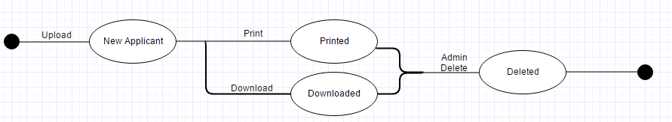

2) Object: ADMIN ACCOUNTS

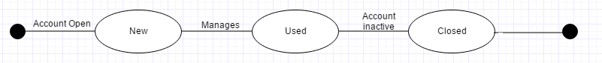

3) Object: BIOMETRICS

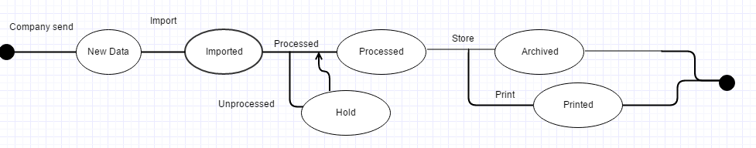

4) Object: PAYSLIP

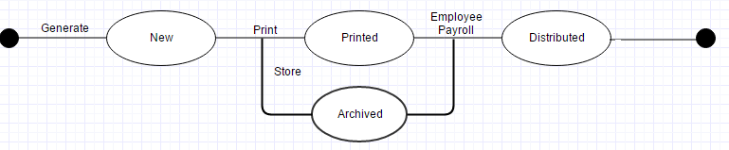

**Sequence Diagrams**

* **ADMIN**

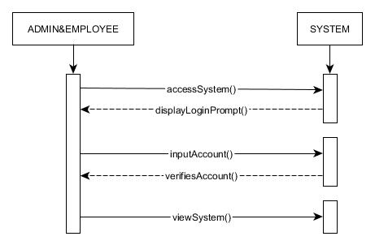

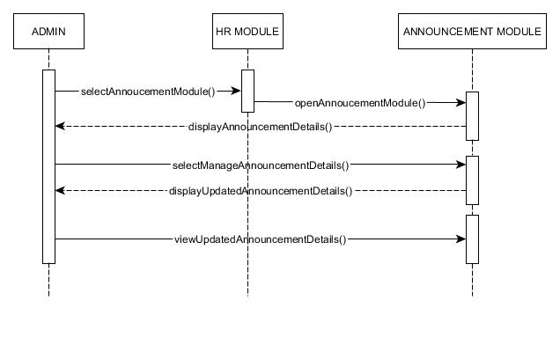

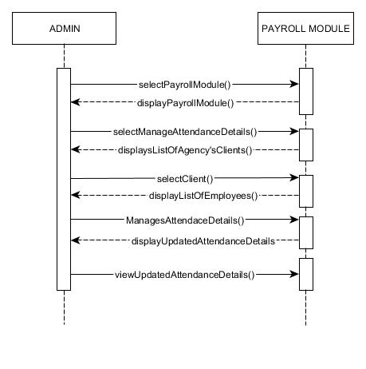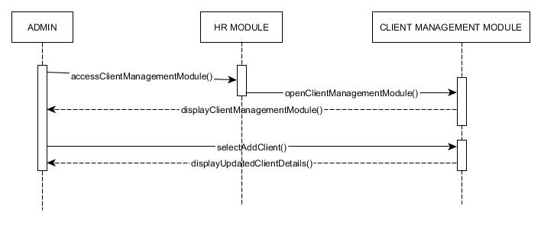

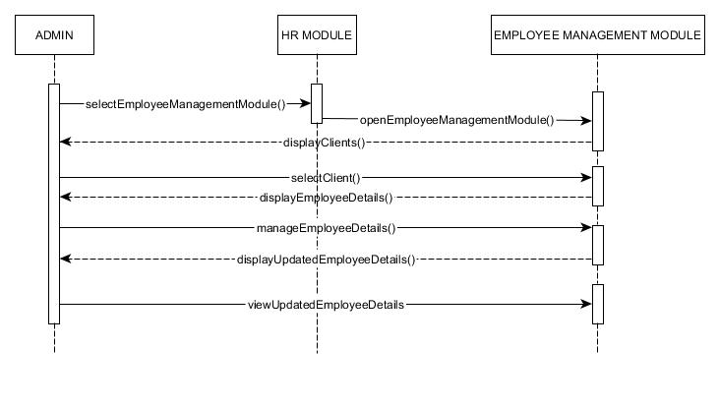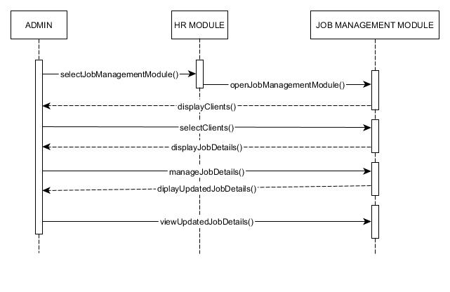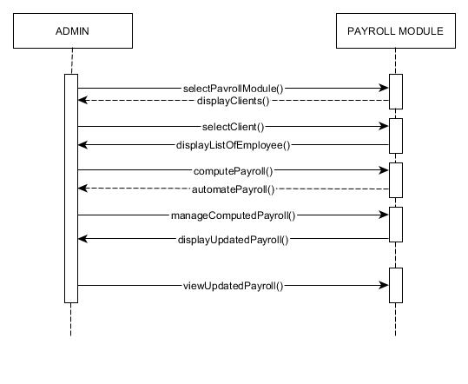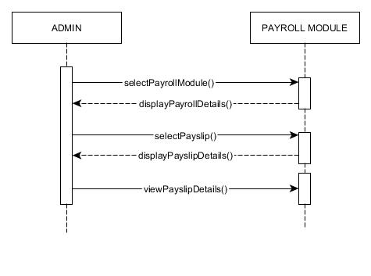

* **APPLICANT**

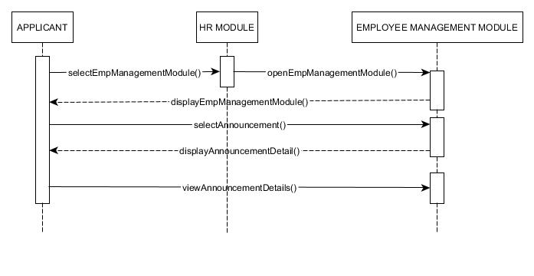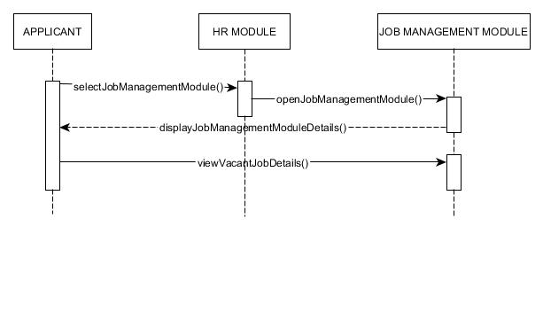

* **EMPLOYEE**

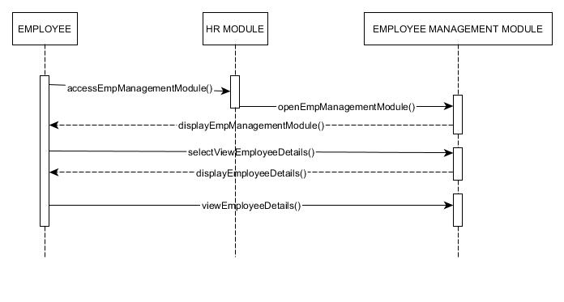

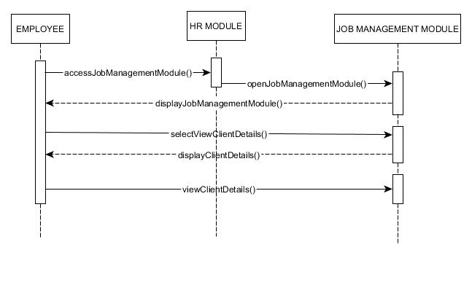

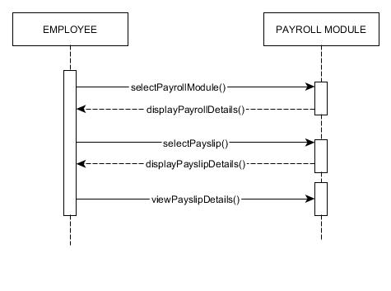

**Activity Diagrams**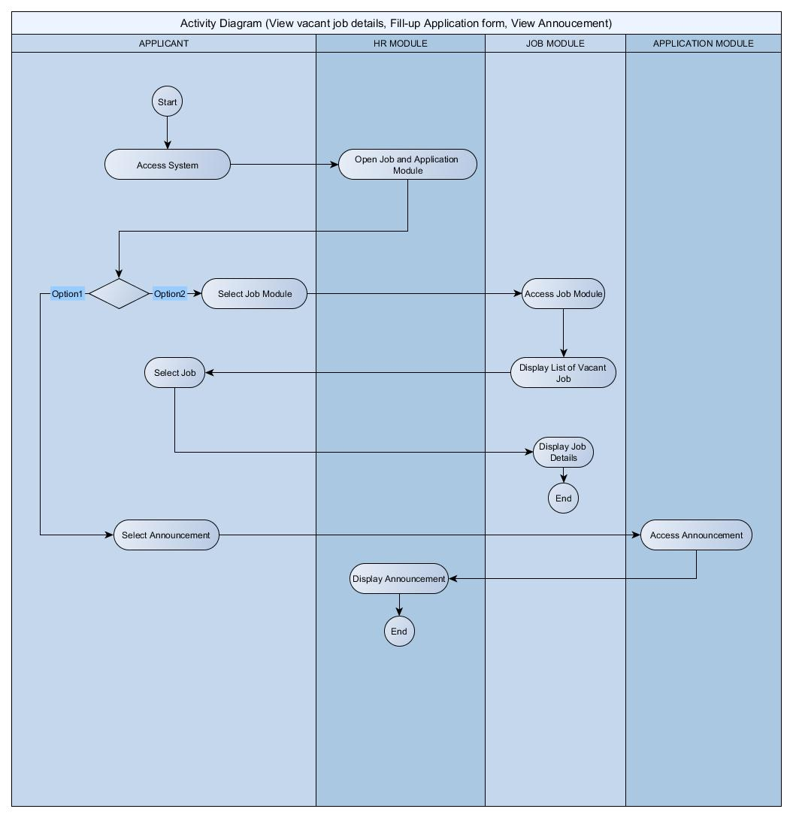

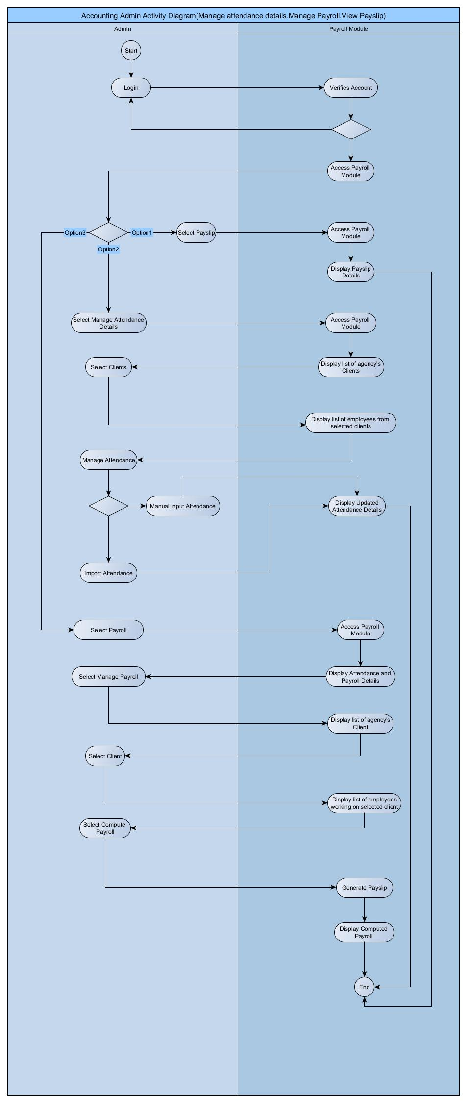

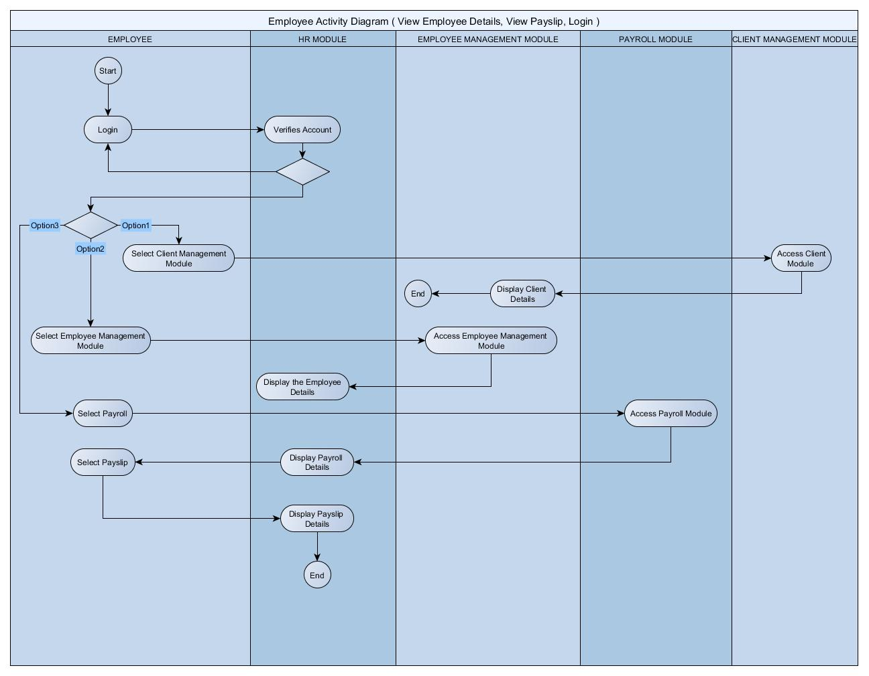

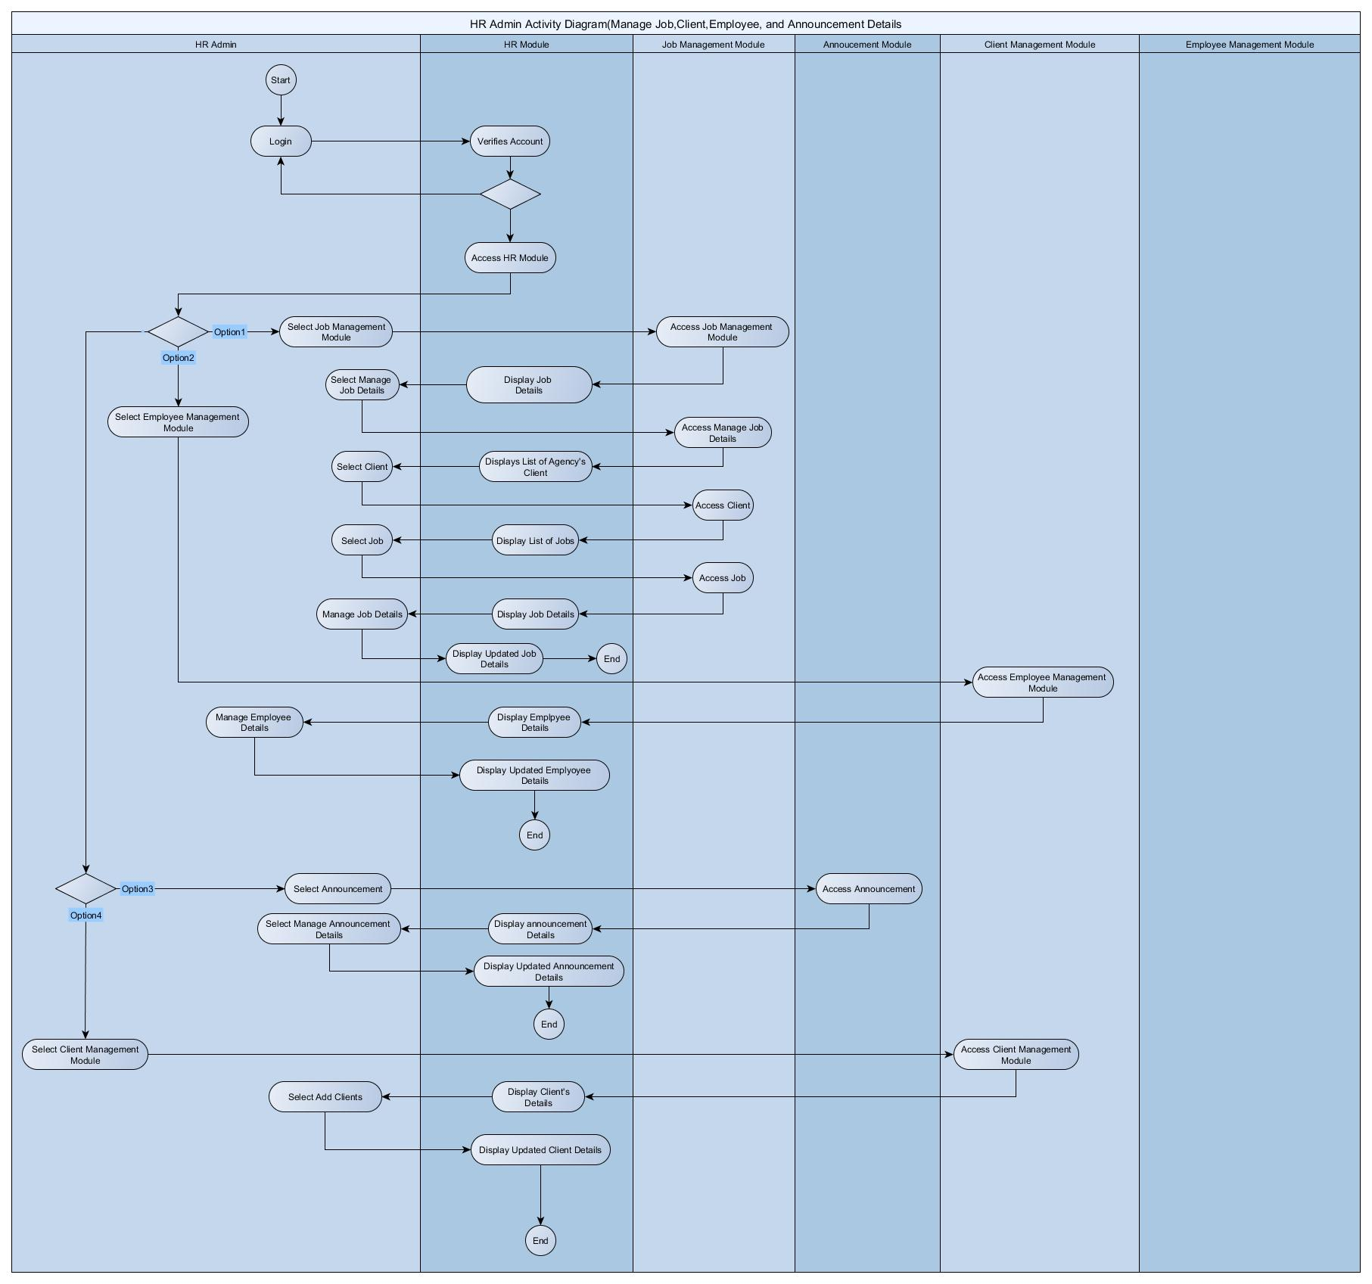

**Component Diagram**

**Deployment Diagram**



May include the following:

- Relevant Source Code

- Evaluation Tool or Test Documents

- Sample input/output/Reports

- Users Guide

- Process/Data/Information Flow

- Screen layouts

- Test Results

- Sample Generated Outputs

- Pictures showcasing the data gathering, investigation done (e.g. floor plan, layout, building, etc.)

- One-Page Curriculum Vitae per team member

**Software Requirements Specifications**

# Introduction

# Purpose

The purpose of the project is to make a Human Resource System that will improve the management of employees decrease the work time greatly.

## 

## **Document Conventions**

The document will be written on standard Arial, 12, single-spacing. Every requirement is to have its own priority

## **Intended Audience and Reading Suggestions**

The documents of the product are intended for the A5MMS Corporation and for the developers who wants to further enhance this product. For the A5MMS, the user must at least read the business case/project overview and the user manual to have a good knowledge on how the system will work, and for the developers, it is suggested to go through the diagrams of the system first rather than the business case.

## **Product Scope**

Refer to the project Vision and Scope

## **References**

[http://projects2.apc.edu.ph/wiki/index.php/Project_-_A5MMS_-_102 [1](http://projects2.apc.edu.ph/wiki/index.php/Project_-_A5MMS_-_102%20%5b1)]

# Overall Description

## **Product Perspective**

The product will be a full replacement of the manual encoding system of the corporation since it their system will be almost completely automated due applicant management system.

## **Product Functions**

The major functions of the products are:

* Applicant Management System
* Client Management System

## User Classes and Characteristics

* A5MMS Office Staff - has complete admin access, can modify data within the system.
* A5MMS Contracted Employees - has no admin access, can only access personal data within the system.
* Ordinary users- has no access to the system internally, can inquire to the system externally

## **Operating Environment**

The system can run at a standard PC with ‘Windows’ as its operating system. The minimum version of the operating system should only be Windows 7 and also we used XAMPP for the server of the system.

## **Design and Implementation Constraints**

There will be a limitation on the development of the automated payroll system since the corporation did not want to share information on how the employees are paid due to confidentiality

## **User Documentation**

Together with the finished product will also include a user-manual on how to operate the system. There is also a hard copy of documentation included on how the system is integrated, and can also be accessed via the projects wiki (look at references [1]).

## **Assumptions and Dependencies**

* The client details are added to the system assuming that they have an agreement.
* The jobs posted in the system should be offered by the agency.
* The applicant details should have verified if he/she hired in the specific client.
* The announcement details should have an approval by the higher position in the agency and the client.

# External Interface Requirements

## **User Interfaces**

To use the system, the user must login to the A5MMS system. For the administrator, he/she able to access the control of the system and for the applicant for them to check their details.

## **Hardware Interfaces**

The hardware component to be used in the system is “Dual Core CPU 2.0GHz” (Minimum required) processor and an 4GB RAM.

## **Software Interfaces**

The product was created through pure PHP development using HTML, CSS and Bootstrap using different web browser that a user may use.

## **Communications Interfaces**

The website would be used in means of communication between the agency, applicants and employee they used different browser to access the system, also can be able to access through smartphones because the system is mobile responsive.

**Description and Priority**

The main priority of the system is the Human Resource Management Module:

* + 1. Stimulus/Response Sequences

The admin manages client details then the system will respond whether if its added, updated, deleted successfully or not.

4.1.3 Functional Requirements

HR module – these are the following use cases for this module which are manage client details, manage applicant details, manage job details, manage announcement details, also for more detailed information of each use cases look for use case narrative. (Refers to appendix B)

## **Performance Requirements**

The response time of the system for the users 95% of all pages visible for the normal people such that the employees and applicants of the company respond in 5.0 seconds or less, this refers to the front end of the system. For the backend of the system respond in just 3.0 sec or less to visible all of the pages in admin part. Also the system handles 50 users simultaneously online.

## **Safety Requirements**

The data provided from the applicants must be accurate, honest, precise and has no missing parts and incorrect information. This product highly gives importance to its criteria which is the reason why data has to be complete and precise.

## **Security Requirements**

This product is highly for Area5 Manpower Management Services and their applicants and employees only, all the information are kept in the system’s database. Only the Administrator will see all what’s in the system but some modules in the system are accessible also to the employees like viewing their pay slip and their profile background only. The applicants may be able to view also the list of jobs.

# Other Requirements

The client can have an access into the system on the future update for them to be able to post jobs and upload list of attendance of each employees/applicant.

**Vision and Scope Project**

# Business Requirements

## **Background**

The A5MMS is a corporation, formed and organized under the laws of the Republic of the Philippines, duly registered with the Security and Exchange Commission (SEC) and licensed to operate a manpower/janitorial services.

The company is managed with hardworking and efficient staff and they’re committed to provide reliable and most trusted recruitment services to the employers ascertaining itself. Over the years, they had been handling documents and processing it manually through Microsoft Word and Excel.

## **Business Opportunity**

The company can accommodate a larger group of applicants and clients if they choose to use the automated system. With that, the company is open to more possible clients and applicants.

## **Business Objectives and Success Criteria**

The main objective of the company is first to provide skilled manpower to their valued clients and second is to provide good opportunities to the candidates who apply through them.

As a success factor to the company’s main objective, the team aims to increase at least 90% of applicants in annual basis.

## **Business Risks**

* The main risk of the company is the time when the government remove the contractualization in the country.
* Increase of market competition is also one of the business risk of the company because of the rapid growth of agency nowadays, with that, they might lose their applicants as well.

# Vision of the Solution

The team’s vision of the proposed system this will be operated and used by the company operationally, that will serve the applicants apply faster.

## **Vision Statement**

To develop a web – based Human Resources Management System for the team to meet the business objective and also the need of improvement of the company.

## **Major Features**

These are the major features of the proposed system:

HR Management Module – this focuses in the human resources and contains the sub – modules such as client management, job management, applicant management modules.

## **Assumptions and Dependencies**

The team assumes that all data of the company will be treated secured and confidential due to the rights of the company.

# Scope and Limitations

The proposed solution to the said problem of the company is to automate their processes to lessen the paper work and increase efficiency of its processes. Therefore the project will only revolve on the Human Resource aspect of the corporation. The system will be able to store applicant information and client information. Admins will only have privileges in terms of editing the information and altering applicant statuses. The Applicant will have an account (without admin privilege) after filling up the application form which the applicant can view his/her information as well as his/her job history.

## **Scope of Subsequent Releases**

Following the initial release of this project, the upcoming major features of the project will be a Human Resource Management system that helps in managing the applicant details; database storage of application forms, and client details.